b
Welcome to

St. Martin’s North East Valley
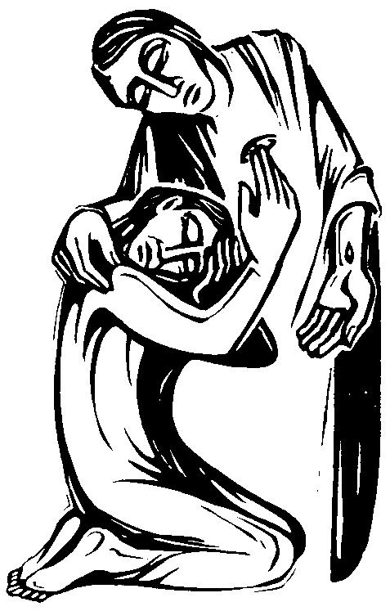

8th April 2018
Second Sunday of Easter!

Presider and Preacher: Rev. Max
Readers: Richard, Mihai
Intercessor: Rev. Ruth
Chalice: Rev. Ruth
Music: Christine

The Ministry of Word and Prayer
The Gathering of the Community
Please stand for the opening hymn and procession
Lord Jesus Christ

Lord Jesus Christ you have come to us
You are one with us, Mary's Son.
Cleansing our souls from all their sin
pouring Your love and goodness in
Jesus our love for you we sing,
living Lord.

Lord Jesus Christ now and every day
Teach us how to pray, Son of God.
You have commanded us to do
this in remembrance Lord of you
Into our lives your power breaks through,
living Lord.

Lord Jesus Christ, you have come to us
Born as one with us, Mary's Son.
Led out to die on Calvary,
risen from death to set us free,
living Lord Jesus help us see
You are Lord.

Lord Jesus Christ I would come to you
live my life for you, Son of God.
All your commands I know are true,
your many gifts will make me new,
into my life your power breaks through,
living Lord.

Priest In the name of the Father, and of the Son, and of the Holy Spirit.
All Amen.

Priest Grace and peace to you from God.
All God fill you with truth and joy.

The Collect for Purity
Almighty God,
to whom all hearts are open,
all desires known,
and from whom no secrets are hidden;
cleanse the thoughts of our hearts
by the inspiration of your Holy Spirit,
so that we may truly love you
and worthily praise your holy name;
through our Saviour, Jesus Christ. Amen.

Priest Hear Hear the teaching of Christ:
you shall love the Lord your God
with all your heart
and with all your soul
and with all your mind
and with all your strength.
This is the first commandment.
And a second is this:
You shall love your neighbour as yourself.
All Spirit of God, search our hearts.

Priest Hear God’s word to all who turn to Christ:
If we confess our sins,
God is faithful and just, and will forgive our sins
and cleanse us
from every kind of wrong.

Priest God has promised forgiveness to all who truly repent,
turn to Christ in faith, and are themselves forgiving.
In silence we call to mind our sins.
Silence
Please sit or kneel

Priest Let us confess our sins
Merciful God,
we have sinned
in what we have thought and said,
in the wrong we have done
and in the good we have not done.
We have sinned in ignorance:
we have sinned in weakness:
we have sinned through our own deliberate fault.
We are truly sorry.
We repent and turn to you.
Forgive us, for our Saviour Christ’s sake,
and renew our lives to the glory of your name. Amen

We sing together the Kyrie

Lord have mercy. Lord have mercy.
Christ have mercy. Christ have mercy.
Lord have mercy. Lord have mercy.

Priest Through the cross of Christ, God have mercy on you,
pardon you and set you free. Know that you are forgiven and be at peace. God strengthen you in all goodness
and keep you in life eternal. Amen

Collect for 2nd Sunday of Easter

Risen Christ,
for whom no door is locked, no entrance barred:
open the doors of our hearts,
that we may seek the good of others
and walk the joyful road of sacrifice and peace,
to the praise of God the Father.
Hear this prayer for your love’s sake.
Amen.

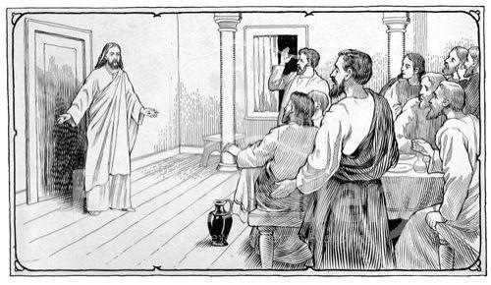

First Reading
Reader A reading from the first book of Acts, chapter 4.
Now the whole group of those who believed were of one heart and soul, and no one claimed private ownership of any possessions, but everything they owned was held in common. With great power the apostles gave their testimony to the resurrection of the Lord Jesus, and great grace was upon them all. There was not a needy person among them, for as many as owned lands or houses sold them and brought the proceeds of what was sold. They laid it at the apostles’ feet, and it was distributed to each as any had need.
Reader Hear what the Spirit is saying to the Church.
All Thanks be to God.

Psalm 133
How very good and pleasant it is
when kindred live together in unity!
It is like the precious oil on the head,
running down upon the beard,
on the beard of Aaron,
running down over the collar of his robes.
It is like the dew of Hermon,
which falls on the mountains of Zion.
For there the Lord ordained his blessing,
life for evermore.

Glory be to the Father
And to the Son,
And to the Holy Spirit.
As it was in the beginning,
is now, and ever shall be,
world without end.
Amen
Second Reading
Reader A reading from John’s first letter.
We declare to you what was from the beginning, what we have heard, what we have seen with our eyes, what we have looked at and touched with our hands, concerning the word of life— this life was revealed, and we have seen it and testify to it, and declare to you the eternal life that was with the Father and was revealed to us— we declare to you what we have seen and heard so that you also may have fellowship with us; and truly our fellowship is with the Father and with his Son Jesus Christ. We are writing these things so that our joy may be complete.
This is the message we have heard from him and proclaim to you, that God is light and in him there is no darkness at all. If we say that we have fellowship with him while we are walking in darkness, we lie and do not do what is true; but if we walk in the light as he himself is in the light, we have fellowship with one another, and the blood of Jesus his Son cleanses us from all sin. If we say that we have no sin, we deceive ourselves, and the truth is not in us. If we confess our sins, he who is faithful and just will forgive us our sins and cleanse us from all unrighteousness. If we say that we have not sinned, we make him a liar, and his word is not in us.
My little children, I am writing these things to you so that you may not sin. But if anyone does sin, we have an advocate with the Father, Jesus Christ the righteous; and he is the atoning sacrifice for our sins, and not for ours only but also for the sins of the whole world.

Reader Hear what the Spirit is saying to the Church.
All Thanks be to God.

Gospel Reading
Please stand

Alleluia, Alleluia
Give thanks to the risen Lord
Alleluia, alleluia, give praise to His name
Spread the good news o'er all the earth
Jesus has died and has risen
Alleluia, Alleluia
Give thanks to the risen Lord
Alleluia, alleluia, give praise to His name

Reader The Holy Gospel of our Lord Jesus Christ, according to John, chapter 20, verses 19 to 31.
All Praise and glory to God.

When it was evening on that day, the first day of the week, and the doors of the house where the disciples had met were locked for fear of the Jews, Jesus came and stood among them and said, “Peace be with you.” After he said this, he showed them his hands and his side. Then the disciples rejoiced when they saw the Lord. Jesus said to them again, “Peace be with you. As the Father has sent me, so I send you.” When he had said this, he breathed on them and said to them, “Receive the Holy Spirit. If you forgive the sins of any, they are forgiven them; if you retain the sins of any, they are retained.” But Thomas (who was called the Twin), one of the twelve, was not with them when Jesus came. So the other disciples told him, “We have seen the Lord.” But he said to them, “Unless I see the mark of the nails in his hands, and put my finger in the mark of the nails and my hand in his side, I will not believe.” A week later his disciples were again in the house, and Thomas was with them. Although the doors were shut, Jesus came and stood among them and said, “Peace be with you.” Then he said to Thomas, “Put your finger here and see my hands. Reach out your hand and put it in my side. Do not doubt but believe.” Thomas answered him, “My Lord and my God!” Jesus said to him, “Have you believed because you have seen me? Blessed are those who have not seen and yet have come to believe.” Now Jesus did many other signs in the presence of his disciples, which are not written in this book. But these are written so that you may come to believe that Jesus is the Messiah, the Son of God, and that through believing you may have life in his name.
Reader This is the Gospel of Christ
All Praise to Christ, the Word.

Alleluia, Alleluia
Give thanks to the risen Lord
Alleluia, alleluia, give praise to His name

Sermon
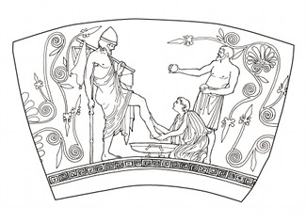

The Nicene Creed
Please stand
We believe in one God, the Father, the Almighty,
maker of heaven and earth, of all that is, seen and unseen.

We believe in one Lord, Jesus Christ,
the only Son of God, eternally begotten of the Father,
God from God, Light from Light, true God from true God, begotten, not made, of one being with the Father;
through him all things were made.
For us and for our salvation he came down from heaven,
was incarnate of the Holy Spirit and the Virgin Mary
and became fully human. For our sake he was crucified under Pontius Pilate; he suffered death and was buried.
On the third day he rose again in accordance with the Scriptures; he ascended into heaven and is seated at the right hand of the Father. He will come again in glory to judge the living and the dead, and his kingdom will have no end.

We believe in the Holy Spirit, the Lord, the giver of life,
who proceeds from the Father and the Son, who in unity with the Father and the Son is worshipped and glorified, and has spoken through the prophets.

We believe in one holy catholic and apostolic Church.
We acknowledge one baptism for the forgiveness of sins.
We look for the resurrection of the dead,
and the life of the world to come. Amen.

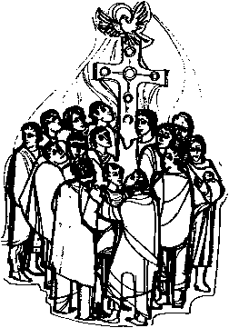
Prayers of Intercession
Please sit or kneel
Priest Let us pray for the Church and for the world,
giving thanks for God’s goodness.

Greeting of Peace
Priest The peace of Christ be with you all.
All And also with you.

Offertory Hymn
During this hymn a collection is taken and the holy table prepared for communion
Make me a channel of your peace
Make me a channel of your peace.
Where there is hatred, let me bring your love;
where there is injury, your pardon, Lord;
and where there's doubt, true faith in you.
O Master, grant that I may never seek
so much to be consoled as to console,
to be understood as to understand,
to be loved as to love with all my soul.
Make me a channel of your peace.
Where there's despair in life, let me bring hope;
where there is darkness, let me bring your light;
and where there's sadness, ever joy.
O Master, grant that I may never seek
so much to be consoled as to console,
to be understood as to understand,
to be loved as to love with all my soul.
Make me a channel of your peace.
It is in pardoning that we are pardoned;
in giving to all people, we receive,
and in dying that we're born to eternal life.
O Master, grant that I may never seek
so much to be consoled as to console,
to be understood as to understand,
to be loved as to love with all my soul.
*
Blessed are you, God of all creation;
through your goodness we have these gifts to share.
Accept and use our offering for your glory
and for the service of your Kingdom
Blessed be God for ever.

The Lord is here.
God’s Spirit is with us.
Lift up your hearts.
We lift them to the Lord.
Let us give thanks to the Lord our God.
It is right to offer thanks and praise.

It is right indeed, it is our joy and our salvation, holy Lord,
Almighty Father, everlasting God, at all times and in all places to give you thanks and praise
through Christ your only Son.

You are the source of all life and goodness;
through your eternal Word
you created all things from the beginning
and formed us in your own image;
male and female you created us.
When we sinned and turned away
you call us back to yourself
and gave your Son to share our human nature.

You raised him to life triumphant over death;
you exalted him in glory.
By his victory over death,
the reign of sin is ended,
a new age has dawned,
a broken world is restored
and we are made whole once more.
In him you have made us a holy people
by sending upon us your holy and lifegiving Spirit.

Therefore with the faithful who rest in him,
with angels and archangels and all the company of heaven,
we proclaim you great and glorious name,
forever praising you and singing:

Holy, holy, holy Lord,
God of power and might,
heaven and earth are full of your glory.
Hosanna in the highest.
Blessed is he who comes in the name of the Lord.
Hosanna in the highest.
All glory and thanksgiving to you, holy Father;
on the night before he died
your Son Jesus Christ took bread
when he had given you thanks,
he broke it, gave it to his disciples and said:
‘This is my body, which is given for you.
Do this to remember me.’
After supper he took the cup;
when he had given you thanks,
he gave it to them and said:
‘Drink this all of you,
for this is my blood of the new covenant
which is shed for you and for many
for the forgiveness of sins;
do this as often as you drink it,
to remember me.’
Glory to you Lord Christ;
your death we show forth,
your resurrection we proclaim,
your coming we await;
Amen, come Lord Jesus.
Therefore loving God,
recalling your great goodness to us in Christ,
his suffering and death,
his resurrection and ascension,
and looking for his coming in glory,
we celebrate our redemption with this bread of life
and this cup of salvation.
Accept our sacrifice of praise and thanksgiving
which we offer through Christ our great high priest.
Send your Holy Spirit
that these gifts of bread and wine which we receive
may be to us the body and blood of Christ,
and that we filled with the Spirit’s grace and power,
may be renewed for the service of your kingdom.

United in Christ with all who stand before you
in earth and heaven,
we worship you, O God,
in songs of everliving praise.
Blessing, honour and glory be yours,
here and everywhere, now and forever. Amen.

Please sit
Te Karakia O Te Atua The Lord’s Prayer

Kua ākona nei tātou e tō tātou Ariki, ka īnoi tātou  E tō mātou Matua i te rangi  Kia tapu tōu Ingoa.  Kia tae mai tōu rangatiratanga.  Kia meatia tāu e pai ai  ki runga ki te whenua,  kia rite anō ki tō te rangi.  Hōmai ki a mātou āianei  he taro mā mātou mō tēnei rā.  Murua ō mātou hara,  Me mātou hoki e muru nei  i ō te hunga e hara ana ki a mātou.  Āua hoki mātou e kawea kia whakawaia;  Engari whakaorangia mātou i te kino:  Nōu hoki te rangatiratanga, te kaha, me te korōria,  Āke ake ake. Āmine. | As our Lord’s Jesus Christ teaches us, so we say  Our Father in heaven,  hallowed be your name,  your kingdom come,  your will be done,  on earth as in heaven.  Give us today our daily bread. Forgive us our sins  as we forgive those who sin against us. Save us from the time of trial and deliver us from evil.  For the kingdom, the power, and the glory are yours  now and for ever. Amen.

The priest breaks the bread.
We break this bread
to share in the body of Christ.
We who are many are one body,
for we all share the one bread.

We sing together the Agnus Dei.

Lamb of God, you take away the sin of the world,
have mercy on us.
Lamb of God, you take away the sin of the world,
have mercy on us.
Lamb of God, you take away the sin of the world,
grant us your peace.

Priest Draw near and receive the body and blood of our Saviour Jesus Christ in remembrance that he died for us. Let us feed on him in our hearts by faith with thanksgiving.
All baptised Christians are welcome to come forward and receive communion
Prayer after Communion

Lord God our Father,
through our Saviour Jesus Christ
you have assured your children of eternal life
and in baptism have made us one with him:
deliver us from the death of sin
and raise us to new life in your love,
in the fellowship of the Holy Spirit,
by the grace of our Lord Jesus Christ.
Amen.

Notices

The Blessing

The God of peace,
who brought again from the dead our Lord Jesus,
that great shepherd of the sheep,
through the blood of the eternal covenant,
make you perfect in every good work to do his will,
working in you that which is well-pleasing in his sight;
and the blessing of God Almighty, Father, Son and Holy Spirit,
be with you now and for ever. Amen!

The Dismissal
Priest He is not here. He is risen. Go in peace to love and serve the Lord. Alleluia, alleluia.
All In the name of Christ. Amen. Alleluia, alleluia.

Closing Hymn
To God be the glory
To God be the glory, great things he has done!
So loved he the world that he gave us his Son,
who yielded his life an atonement for sin
and opened the life-gate that all may go in.
Praise the Lord! Praise the Lord!
Let the earth hear his voice!
Praise the Lord! Praise the Lord!
Let the people rejoice!
O come to the Father, through Jesus the Son,
and give him the glory! Great things he has done!
O perfect redemption, the purchase of blood!
To every believer the promise of God!
The vilest offender who truly believes,
that moment from Jesus forgiveness receives.
Praise the Lord! Praise the Lord! …
Great things he has taught us, great things he has done,
and great our rejoicing through Jesus the Son;
but purer and higher and greater will be
our wonder, our rapture, when Jesus we see.
Praise the Lord! Praise the Lord! …

Prayers

The Church For bishop Steven Benford, the clergy and people of All Saints’, St. Martin’s and St. Thomas’s. For Christians throughout the world, especially those who take great risk to live out their faith.
The World Refugees. The people of Palestine and Israel, Syria, Afganistan, and Iraq. Those affected by earthquakes and other natural disasters. Victims of wars both past and present. For peace.
The Community Residents and staff of Ross Home and Otago Community Hospice. The elderly and lonely. Children and youth ministries. The Toy Library. All Saints’ Fruit and Vege Co-op. Students and staff of the University and Polytech.
The sick All those who we know are sick or suffering in body, mind, or spirit.

Notices
• Fruit & Veges Is now up and running again (Thursdays 4.30pm-6pm) If you would like to be involved in this ministry, please talk to Audrey.
• Hall hire: If you know anyone who would like to hire any of the hall in the parish please let Nicki in the parish office know (479 2212).
• Regular giving: Thank you to those who are giving regularly to the parish by electronic transfer or through the envelope scheme. Vestry encourages everyone involved in the parish to reflect on how much they are giving to the parish and to consider increasing their contribution to sustain and build the ministries offered here. Parish bank account. Bank: ANZ. Branch: Octagon. Account name: All Saints. Account number: 06 0901 0401135 00. If you have any questions please ask Margaret Rockliff or David Fielding.
• Prayer and Spiritual life. If you would like to speak with someone about your prayer life please speak with one of the clergy. You might like to visit these prayer websites: www.sacredspace.ie & www.pray-as-you-go.org Spiritual direction is recommended for everyone serious about their spiritual life. It is a pastoral ministry in which one Christian helps another to: pay attention to God’s personal communication to him/her, to respond to and grow in intimacy with God and to live out the consequences of this relationship. Spiritual direction offers quality listening and assistance in hearing God's voice, reflecting on the journey and facing into the movements of grace in our lives. Ask one of the clergy about this or visit the website of the association of Christian Spiritual Directors: www.acsd.org.nz or the website of Spiritual growth ministries www.sgm.org.nz
• Pastoral care If you would like a pastoral visit for any reason please contact Fr. Max, Fr. Michael, or Jo Dodd 4770956.

• Pilgrim Course. This year during Lent, All Saints’ will be offering a discipleship course for those who want to learn what it means to follow Jesus. This course is open to everyone, no matter where you are on your faith journey. This is an 8 week course commencing on Tuesday 6th March, with 4 weeks before Easter and 4 weeks after Easter. For further information on course content please go to www.pilgrimcourse.org
Time: 7.00pm Venue: All Saints’. For further information and to register, please contact Fr. Michael on 03 477 8300 or vicar@allsaintsdn.org.nz Everyone is welcome!
• C&Q Youth group for intermediate and high school pupils meets this term 7-9pm:

Next Week’s Roster

Preacher Rev Max
Readers Lucille, Gillian
Intercessions Gillian
Chalice Richard
Music Sam

Next Week’s Readings

First Reading Acts 3:12-19
Epistle 1 John 3:1-17
Psalm 4
Gospel Luke 24:36b-48

Contact Details

Email: mrmaxwhitaker@gmail.com
Phone/txt: 0212972488
Please visit us at www.saintmartinsnev.com
North East Valley Anglicans

